Xamarin Mobile Apps Development

Start Here Videos: <https://developer.xamarin.com/videos>

* Start Installation – either OSX or Windows
  + Mac
    - Prepare XCode & iOS Simulator
    - Free Provisioning [here](https://developer.xamarin.com/guides/ios/getting_started/installation/device_provisioning/free-provisioning/#Launching_your_App) & [here](https://developer.xamarin.com/guides/ios/getting_started/installation/device_provisioning/free-provisioning/)
  + Windows:
    - Download & Install Visual Studio 2015 Community. Do not check ANY Cross Platform boxes
    - Download Xamarin Add-on from [here](https://www.xamarin.com/download). Check the box ‘I already have Visual Studio Installed’
* Tips Setup Visual Studio for Android
  + Always use Visual Studio Emulator for Android device(if you have Hyper-V on your computer)
    - **Close everything except Visual Studio – (it needs a lot of memory)**
    - Goto Tools -> Visual Studio Emulator for Android
    - If your computer have 4GB Memory or less, choose device requires **only** **1GB RAM**

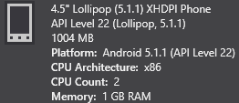

* + - Launch the device directly from the emulator then unlock the phone
    - Click the green triangle to run & debug the device from VS toolbar



* + - You should see ‘Deploying ... ‘ on the bottom of the Visual Studio status bar
  + Setup WiFi using C:\Program Files (x86)\Android\android-sdk\platform-tools\adb.exe
    - **Setup WiFi:** 1. Plugin USB 2. **adb tcpip 5555**
    - **Connect WiFi:** 1. Unplug USB 2. **adb connect 192.168.x.x:5555**
    - **List:** adb devices
    - **Reset back to USB:** **adb usb**
    - [Reference](https://developer.xamarin.com/guides/android/getting_started/installation/set_up_device_for_development/#Connect_the_Device_to_the_Computer)
* Tips Setup Visual Studio for iOS
  + Mac side:
    - Setup Sharing -> Remote Login -> Add user for ‘allow access’
    - Find out your ‘Username’. NOT the same as your Full Name. (You will see your username when you open the ‘Terminal’ App)
  + Visual Studio side:
    - Tools -> iOS -> Xamarin Mac Agent -> Select Your Mac -> Click ‘Connect’ -> Provide your username & password -> Click ‘Login'
    - In Solution Platform on Toolbar Choose ‘iPhone Simulator’



* + - Build & Debug/Run

# Beginner’s tutorial

* [Get Started Series](https://developer.xamarin.com/guides/xamarin-forms/getting-started/) - probably just a. Hello, Xamarin.Forms & b. Hello, Xamarin.Forms Multiscreen
* Forum: <http://forums.xamarin.com/categories/xamarin-forms>
* [Xamarin.Forms Kickstarter 2.0](http://www.xforms-kickstarter.com)
* User Interface
  + [General Non Html UI](https://developer.xamarin.com/guides/xamarin-forms/user-interface)
  + [Image](https://developer.xamarin.com/guides/xamarin-forms/working-with/images)
    - [Also implemented in phoneword](https://vincenthome.visualstudio.com/defaultcollection/Phoneword/Phoneword%20Team/_git/Phoneword)
  + [Html Web View](https://developer.xamarin.com/guides/xamarin-forms/user-interface/webview/)
  + [Animation](https://developer.xamarin.com/api/type/Xamarin.Forms.AnimationExtensions)
    - <http://www.redbitdev.com/cross-platform-animations-using-xamarin-forms>
    - [Also implemented in phoneword](https://vincenthome.visualstudio.com/defaultcollection/Phoneword/Phoneword%20Team/_git/Phoneword)
  + [References](https://developer.xamarin.com/guides/xamarin-forms/controls/)
* [Consuming Web Services](https://developer.xamarin.com/guides/xamarin-forms/web-services)
  + [Restful](https://developer.xamarin.com/guides/xamarin-forms/web-services/consuming/rest)
    - [Also implemented in phoneword](https://vincenthome.visualstudio.com/defaultcollection/Phoneword/Phoneword%20Team/_git/Phoneword)
  + [Azure App Service Mobile App](https://developer.xamarin.com/guides/xamarin-forms/web-services/consuming/azure)
* [Charles Petzold Free ebook](https://developer.xamarin.com/guides/xamarin-forms/creating-mobile-apps-xamarin-forms/) - too long
* Azure Mobile Apps Service
  + [Talking to Azure Cloud Mobile Apps backend](https://azure.microsoft.com/en-us/documentation/articles/app-service-mobile-xamarin-forms-get-started/)
  + [Articles organized by Xamarin.com](https://developer.xamarin.com/guides/cross-platform/azure/mobile-services/)
  + [Authentication by Xamarin.com](https://developer.xamarin.com/guides/xamarin-forms/web-services/authentication/azure/)
  + <https://developer.xamarin.com/guides/cross-platform/azure/>
* Azure App Service <https://azure.microsoft.com/en-us/documentation/services/app-service>
  + Azure WebApp <https://azure.microsoft.com/en-us/documentation/services/app-service/web>
  + Azure MobileApp <https://azure.microsoft.com/en-us/documentation/learning-paths/appservice-mobileapps>
    - [Xamarin.Form Mobile App Server & Client Walkthrough](https://azure.microsoft.com/en-us/documentation/articles/app-service-mobile-xamarin-forms-get-started) 
      * [.NET Mobile App Server Backend SDK](https://azure.microsoft.com/en-us/documentation/articles/app-service-mobile-dotnet-backend-how-to-use-server-sdk)
      * [.NET Xamarin.Form Mobile App Client SDK](https://azure.microsoft.com/en-us/documentation/articles/app-service-mobile-dotnet-how-to-use-client-library)
        + 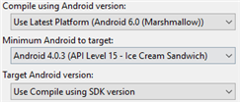
      * [Authentication for Mobile App Client & Server](https://azure.microsoft.com/en-us/documentation/articles/app-service-mobile-xamarin-forms-get-started-users)
        + Azure Portal: Add Mobile App Authentication

Choose ‘Allow request (no action)’

Identity Provider Setup & Tips

[AzureAD](https://azure.microsoft.com/en-us/documentation/articles/app-service-mobile-how-to-configure-active-directory-authentication/)

‘Express’ is broken! Follow the ‘(Alternative method) Manually configure …’

[Facebook](https://azure.microsoft.com/en-us/documentation/articles/app-service-mobile-how-to-configure-facebook-authentication/)

[Google](https://azure.microsoft.com/en-us/documentation/articles/app-service-mobile-how-to-configure-google-authentication/)

[Microsoft](https://azure.microsoft.com/en-us/documentation/articles/app-service-mobile-how-to-configure-microsoft-authentication/)

* + - * + [Mobile App Server](https://azure.microsoft.com/en-us/documentation/articles/app-service-mobile-xamarin-forms-get-started-users/#restrict-permissions-to-authenticated-users) – Add **[Authorize]** to Controller/Action
        + [Mobile App Client Xamarin.Form](https://azure.microsoft.com/en-us/documentation/articles/app-service-mobile-xamarin-forms-get-started-users/#add-authentication-to-the-portable-class-library): 1. IAuthenticate 2. Xaml UI
        + Mobile App Client [Android](https://azure.microsoft.com/en-us/documentation/articles/app-service-mobile-xamarin-forms-get-started-users/#add-authentication-to-the-android-app) / [iOS](https://azure.microsoft.com/en-us/documentation/articles/app-service-mobile-xamarin-forms-get-started-users/#add-authentication-to-the-ios-app) :

Simulator won’t work

Use MobileServiceUser.UserId to access user specific data from DB

* + - * [Push Notification for Mobile App Server, Google Cloud Messaging GCM & Apple APNS](https://azure.microsoft.com/en-us/documentation/articles/app-service-mobile-xamarin-forms-get-started-push)
        + Azure Portal: Add Mobile App Push [Notification Hub](https://azure.microsoft.com/en-us/documentation/articles/app-service-mobile-xamarin-forms-get-started-push/#create-a-notification-hub-for-your-mobile-app)
        + [Mobile App Server](https://azure.microsoft.com/en-us/documentation/articles/app-service-mobile-xamarin-forms-get-started-push/#update-the-server-project-to-send-push-notifications) **Send** Push Notification

[Templates](https://azure.microsoft.com/en-us/documentation/articles/notification-hubs-templates/)

* + - * + Mobile App Client [Android](https://azure.microsoft.com/en-us/documentation/articles/app-service-mobile-xamarin-forms-get-started-push/#optional-configure-and-run-the-android-project) – Add Push Notification Receiver

Setup GCM in Google Cloud Console & Azure Portal Mobile App

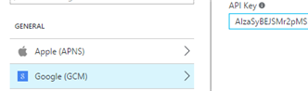

* + - * + Mobile App Client [iOS](https://azure.microsoft.com/en-us/documentation/articles/app-service-mobile-xamarin-forms-get-started-push/#optional-configure-and-run-the-ios-project) – Add Push Notification Receiver

Setup APNS in & Azure Portal Mobile App

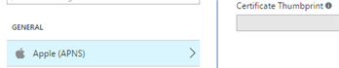

* + Function App <https://azure.microsoft.com/en-us/documentation/articles/functions-overview>
    - [C# Function Reference](https://azure.microsoft.com/en-us/documentation/articles/functions-reference-csharp/)

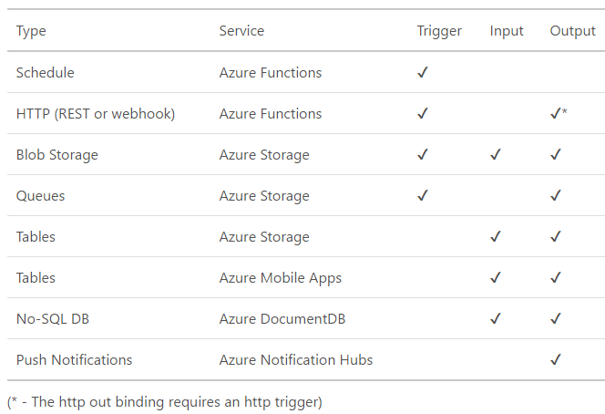

* + - [Upload Additional Files](https://azure.microsoft.com/en-us/documentation/articles/functions-reference/#fileupdate) & [Here](http://stackoverflow.com/questions/36411536/how-can-i-use-nuget-packages-in-my-azure-functions)
    - Trigger  *– function.json type*
      * [timerTrigger](https://azure.microsoft.com/en-us/documentation/articles/functions-triggers-bindings/#timer-trigger) /w **TimerInfo** **input** param
      * [httpTrigger](https://azure.microsoft.com/en-us/documentation/articles/functions-triggers-bindings/#http-and-webhook-triggers-and-bindings) (WebHook/Standard) /w **HttpRequestMessage** **input** param
      * [queueTrigger](https://azure.microsoft.com/en-us/documentation/articles/functions-triggers-bindings/#storagequeuetrigger)
      * [blobTrigger](https://azure.microsoft.com/en-us/documentation/articles/functions-triggers-bindings/#storageblobtrigger)
    - Input Bindings  *– function.json type*
      * [table](https://azure.microsoft.com/en-us/documentation/articles/functions-triggers-bindings/#storagetablesbindings) (2 ways)
      * [mobileTable](https://azure.microsoft.com/en-us/documentation/articles/functions-triggers-bindings/#mobiletablesinput) for Mobile App (2 ways)
      * [blob](https://azure.microsoft.com/en-us/documentation/articles/functions-triggers-bindings/#storageblobbindings) (2 ways)
      * [documentdb](https://azure.microsoft.com/en-us/documentation/articles/functions-triggers-bindings/#storageblobbindings) (2 ways)
    - Output Bindings *– function.json type*
      * [queue](https://azure.microsoft.com/en-us/documentation/articles/functions-triggers-bindings/#storagequeueoutput) will Trigger provide input data? Or just output ONLY?
      * [table](https://azure.microsoft.com/en-us/documentation/articles/functions-triggers-bindings/#storagetablesbindings) (2 ways)
      * [mobileTable](https://azure.microsoft.com/en-us/documentation/articles/functions-triggers-bindings/#mobiletablesoutput) for Mobile App (2 ways)
      * [blob](https://azure.microsoft.com/en-us/documentation/articles/functions-triggers-bindings/#storageblobbindings) (2 ways)
      * [documentdb](https://azure.microsoft.com/en-us/documentation/articles/functions-triggers-bindings/#docdboutput) (2 ways)
      * [notificationHub](https://azure.microsoft.com/en-us/documentation/articles/functions-triggers-bindings/#azure-notification-hub-output-binding) Output ONLY
  + API/Logic Apps seems less useful!